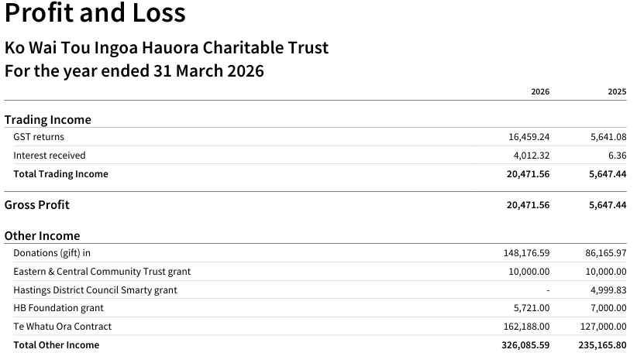

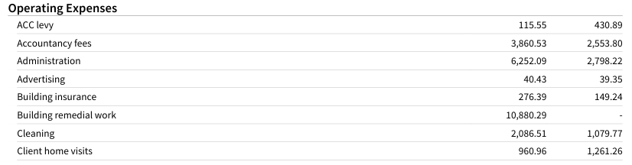

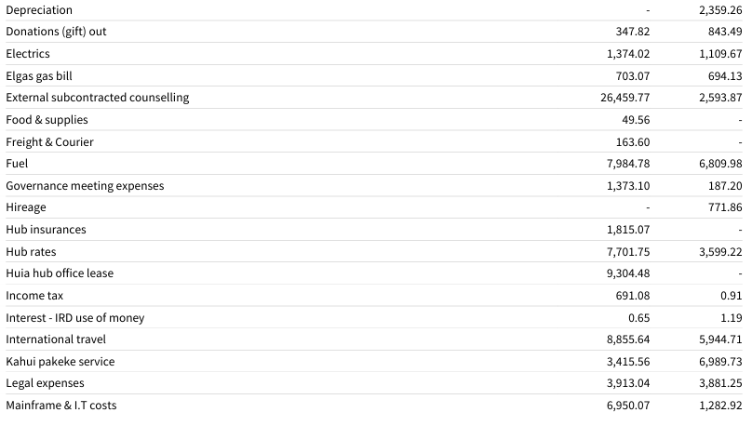


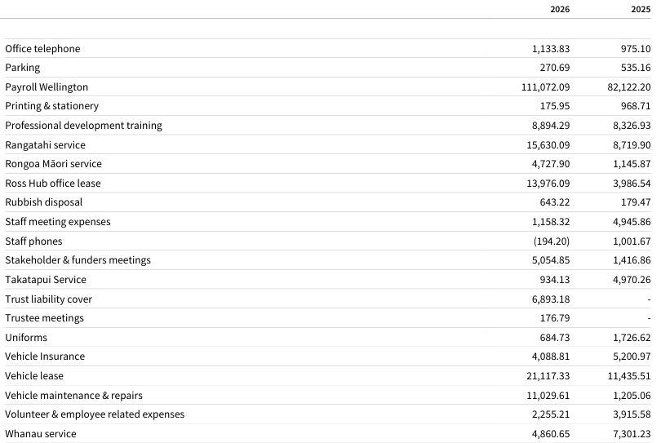

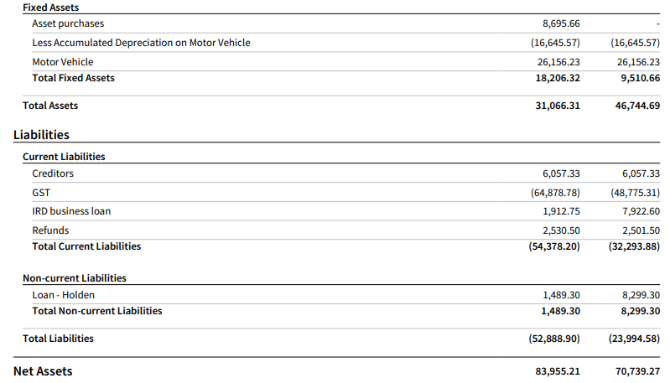
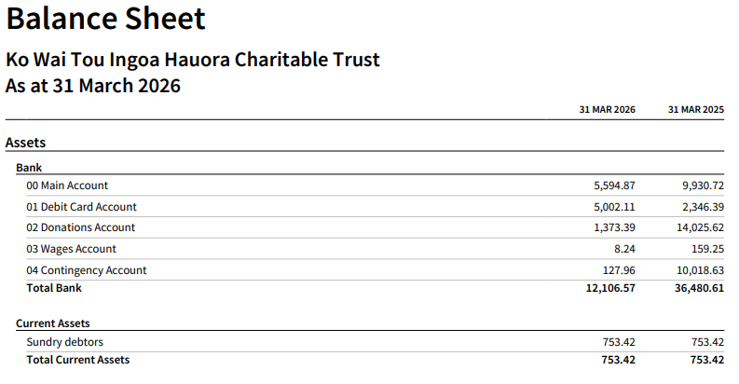
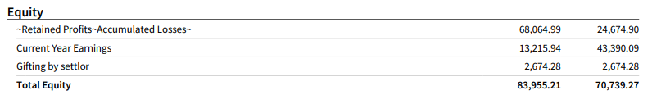

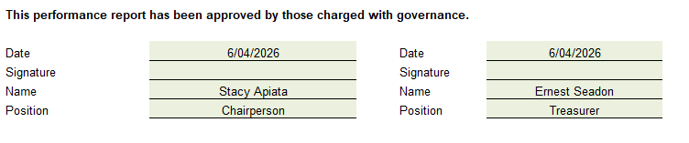

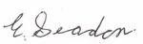


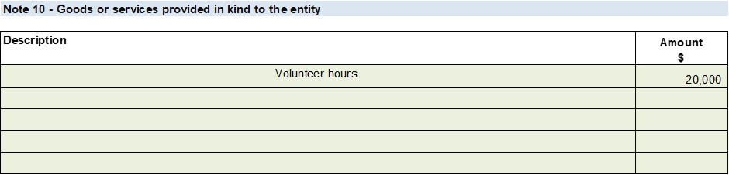
Based on the financial reports provided, the Trust has maintained a sound financial position, with sufficient revenue from donations, grants, and other fundraising activities to meet its ongoing commitments. Expenses have been managed prudently, and cash flow remains adequate to support operational requirements. The Trustees are satisfied that the Trust is able to continue operating and delivering its services in line with its objectives for the foreseeable future.
